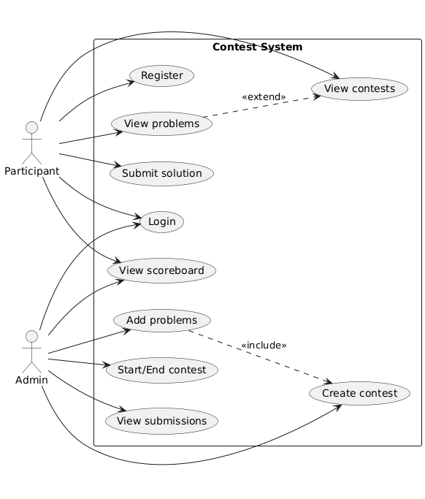
Use Case Diagram Description
This diagram represents a Use Case Diagram for the Contest System.
It shows the functional requirements of the system and how different types of users interact with it.
Actors
The system has two main actors:
- Participant — a regular user who takes part in contests.
- Admin — a system administrator responsible for managing contests.
Participant Use Cases
From the diagram, we can see that a Participant can:
- Register and log in to the system
- View available contests
- Optionally view problems after selecting a contest
- Submit solutions to problems
- View the scoreboard to see results and rankings
This shows the typical user flow of a participant in a contest-based platform.
Admin Use Cases
The Admin has access to management functionality, including:
- Creating contests
- Adding problems to contests
- Starting and ending contests
- Viewing submitted solutions
- Viewing the scoreboard
These use cases demonstrate that the Admin controls the lifecycle of contests and monitors user activity.
Relationships Between Use Cases
The diagram also illustrates relationships between use cases:
- View problems is modeled as an extension of View contests, meaning problems are displayed only when a specific contest is selected.
- Add problems includes Create contest, indicating that a contest must exist before problems can be added.
What We Understand From This Diagram
From this diagram, we can understand:
- Who can use the system and what actions they are allowed to perform
- The main functionality provided by the system
- The separation of responsibilities between regular users and administrators
- The overall behavior and expected interactions within the system
This diagram helps define the scope of the project and serves as a foundation for system design and implementation.

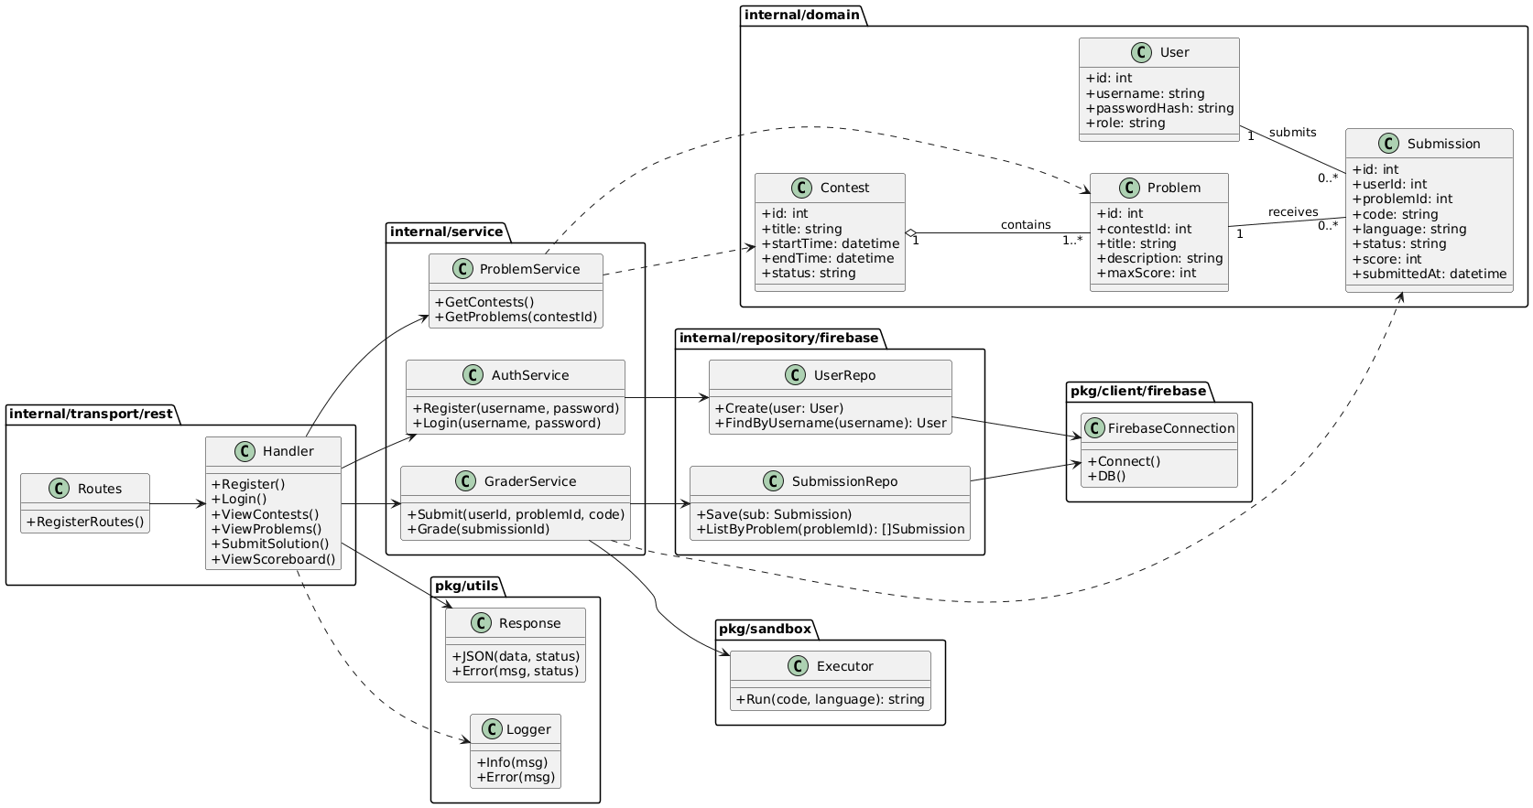
This UML diagram describes the internal structure of the Contest System based on the current Go project layout. It combines domain models with the main application layers (transport, service, repository), showing how the system is organized inside a monolithic architecture.
Domain Layer (internal/domain)
The core data entities of the system are represented in the domain package:
- User — stores user identity, login data and role (participant/admin).
- Contest — represents a contest with time boundaries and status.
- Problem — describes tasks inside a contest, including title, description, and max score.
- Submission — stores solution attempts including code, language, status, score, and timestamp.
The diagram also shows key relationships:
- One Contest contains many Problems (1..*).
- One User can create many Submissions.
- One Problem can receive many Submissions.
Transport Layer (internal/transport/rest)
This layer handles HTTP requests:
- Routes configures API endpoints.
- Handler processes incoming requests and returns JSON responses.
Handlers do not contain business logic; they delegate work to the service layer.
Service Layer (internal/service)
The service layer contains the main business logic:
- AuthService — registration and login logic.
- ProblemService — loading contests and problems.
- GraderService — submission processing and grading workflow.
Services use repositories to access persistent storage and domain models to represent data.
Repository Layer (internal/repository/firebase)
Repositories isolate database logic from the rest of the application:
- UserRepo performs CRUD operations for users.
- SubmissionRepo stores and reads submissions.
Both repositories depend on the Firebase connection module.
External/Shared Modules (pkg)
The diagram includes shared infrastructure modules:
- FirebaseConnection (pkg/client/firebase) — provides the connection to Firebase (database client).
- Executor (pkg/sandbox) — responsible for running/evaluating submitted code (can be a mock at milestone stage).
- Logger and Response (pkg/utils) — utilities for logging and consistent API responses.
What We Understand From This Diagram
From this UML diagram we understand:
- The project follows a layered monolithic architecture.
- Each layer has a clear responsibility (REST → Service → Repository → DB).
- Domain entities are used across the system as shared data models.
- The design supports clean separation of concerns, easier testing, and maintainability.

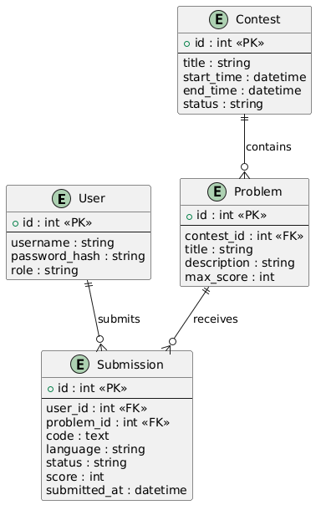
Entity Relationship Diagram Description
This Entity Relationship Diagram (ERD) represents the database structure of the Contest System and shows how data entities are related to each other.
Entities
The system consists of four main entities:
- User — stores information about system users, including authentication data and role.
- Contest — represents a programming contest with start and end time.
- Problem — represents a task that belongs to a specific contest.
- Submission — represents a solution submitted by a user for a problem.
Relationships
The diagram defines the following relationships:
- A User can submit multiple Submissions, but each Submission belongs to exactly one User (1-to-many).
- A Problem can have multiple Submissions, but each Submission is related to only one Problem (1-to-many).
- A Contest contains multiple Problems, and each Problem belongs to one Contest (1-to-many).
What We Understand From This Diagram
From this ERD, we understand:
- How data is stored in the system
- How entities are connected through foreign keys
- How submissions link users and problems
- How contests logically group problems
This diagram serves as a foundation for database design and repository implementation.

Modules, Responsibilities, and Data Flow
System Architecture (Monolith)
The project is implemented as a monolithic Go application. All functionality (REST API, business logic, and data access) is delivered in one deployable program, but internally it is separated into layers and modules to keep responsibilities clear and the code maintainable.
The main layers follow this flow:
Client → Transport (REST) → Service → Repository → Firebase (DB) → Response

Modules and Responsibilities
1) Transport Layer (internal/transport/rest)
Purpose: Handle HTTP requests and responses.
Key responsibilities:
- Define REST routes/endpoints (routes)
- Parse request input (path/query/body)
- Basic validation of input format
- Call the appropriate service method
- Return standardized JSON responses (success/error)
Important rule: Transport does not contain business logic; it delegates to services.

2) Service Layer (internal/service)
Purpose: Implement the project’s business logic.
Key responsibilities:
- Apply system rules (who can do what, contest timing, scoring rules)
- Validate business constraints (e.g., contest exists, problem belongs to contest)
- Orchestrate multiple actions across repositories and utilities
- Prepare final results for handlers (status, score, errors)
Example services:
- AuthService: registration, login logic, password hashing rules
- ProblemService: retrieving contests and problems
- GraderService: submission processing, calling sandbox/executor, assigning status/score

3) Repository Layer (internal/repository/firebase)
Purpose: Isolate persistence logic (database operations).
Key responsibilities:
- CRUD operations for entities (User, Submission, etc.)
- Convert domain objects to database documents and back
- Keep database-related code out of services and handlers
- Provide a stable API even if DB changes later
Repositories depend on the Firebase client module.

4) Domain Layer (internal/domain)
Purpose: Define core data models.
Key responsibilities:
- Store entity structures: User, Contest, Problem, Submission
- Provide a consistent representation of data across the entire application
- Keep domain objects independent from transport and database details

5) Shared / Infrastructure Modules (pkg/*)
Purpose: Reusable utilities and technical components.
Examples:
- pkg/client/firebase: initializes Firebase connection and provides access to the database client
- pkg/sandbox: executes or simulates execution of submitted code (for milestone stage it can be a mock)
- pkg/utils: logger and response helpers to keep endpoints consistent

Data Flow (Main Scenarios)
A) Registration / Login Flow
- The client sends a request to the REST API (e.g., POST /register or POST /login).
- Handler reads input data and validates basic format.
- Handler calls AuthService.
- AuthService applies business rules (e.g., user uniqueness, password hashing).
- AuthService uses UserRepo to store or retrieve a user in Firebase.
- Repository uses FirebaseConnection to interact with the database.
- Service returns the result to Handler.
- Handler sends a JSON response to the client.
Flow: Client → Handler → AuthService → UserRepo → Firebase → Handler → Client

B) Submit Solution Flow (core flow)
- The client sends POST /submit with problemId, language, and code.
- Handler checks the input format and calls GraderService.
- GraderService validates business rules (problem exists, contest state allows submissions, etc.).
- The service calls Sandbox Executor (or mock) to evaluate the solution and obtain a result.
- The service calculates final status (Accepted/Wrong Answer) and score.
- The service saves the submission through SubmissionRepo into Firebase.
- The service returns submission result to Handler.
- Handler returns JSON response with status and score.
Flow: Client → Handler → GraderService → Executor → SubmissionRepo → Firebase → Handler → Client

Why This Design Works
This architecture ensures:
- Clear separation of concerns (REST / business logic / persistence)
- Easier testing (services can be tested without HTTP layer)
- Maintainability and future extension (e.g., adding ScoreboardService or switching DB later)
- Monolith compliance with the assignment requirements while keeping internal modules clean and scalable

